

|  |  |  |  |  |  |
| --- | --- | --- | --- | --- | --- |
| **NAME** |  | | | | |
| **SUBJECT** | **BASIC TECHNOLOGY** | **CLASS** | **JSS 3** | **DURATION** | **2 HOURS** |

**SECTION B: BASIC TECHNOLOGY**

1. Economic activities in technology includes the following EXCEPT ______
2. transportation
3. product distribution
4. food preservation
5. communication
6. Workshop hazards can be prevented by ______
7. giving first aid
8. avoid use of machines
9. obeying safety rules
10. working very well
11. Which of the following is NOT part of electric circuit?
12. Magnet
13. Cell
14. Voltmeter
15. Variable resistor
16. Which of the following is NOT used as roofing materials?

A. Zinc

B. Grass

C. Asbestos

D. Cotton

1. The properties of a metal to crack easily is known as
   1. hardness
   2. toughness
   3. brittleness
   4. strenght
2. In technical drawing the inclined lines at 450 , 600 and 300 are drawn using
   1. frnch curve
   2. Tee square only
   3. Tee square and set squares
   4. templates
3. A platform on which woodworkers perform operation is known as _______
   1. Bench vice
   2. Work bench
   3. Machine vice
   4. Work table
4. The tool used for cutting external thread is called
   1. tap
   2. hacksaw
   3. chisel
   4. twist drill
5. First aid record book is used for the following EXCEPT the recording of the
   1. Information of the victim
   2. Scores of the victim
   3. Nature of wound
   4. Type of treatment giving
6. Which of the following isNOT used in rescue operation?
   1. Digger
   2. Shovel
   3. Whistle
   4. Trowel
7. Which of these metal is used for making cutting tools?
8. High carbon steel
9. Mild steel
10. Cast iron
11. Aluminium
12. 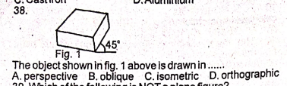The object shown in the figure below is drawn in _________
    1. perspective
    2. oblique
    3. isometric
    4. orthographic

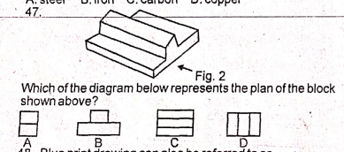

Which of the diagram below represents the plan of the block shown above?



1. Which of the following joint is used to construct simple woodwork box?
   1. Butt joint
   2. Tongue and grove joint
   3. tongue and groove joint
   4. halving joint
2. A file without handle should not be used in the workshop because it
   1. will not file well
   2. can pierce the hand
   3. Will affect the work
   4. May cause breakage
3. Which of the following is NOT a permanent way of joining metals?
   1. Bolt and nut
   2. Brazing
   3. Riveting
   4. Soldering
4. The following professionals can work in oil and gas company EXCEPT ____
   1. Mechanical engineer
   2. Petroleum engineer
   3. Aeronautic engineer
   4. Safety engineer
5. The type of drawing which shows the interior parts of an object is known as ____
6. Orthographic drawing
7. Pictorial drawing
8. Sectional drawing
9. Perspective drawing
10. Site preparation include the following EXCEPT
    1. Uprooting of trees
    2. levelling
    3. moulding blocks
    4. removal of existing structure
11. The diagram below represents a/an.........

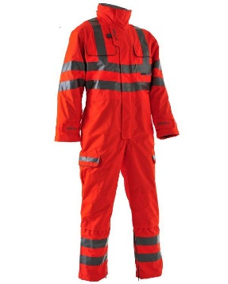

* 1. Safety boot
  2. Overall
  3. Sport wear
  4. garment

1. Which of the following symbols represents a resistor?

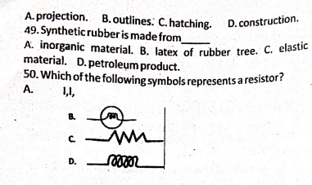

1. Cutting grove and slot in metals can be carried out with
   1. Grinding machine
   2. Lathe machine
   3. harmonic motion
   4. reciprocating motion
2. Which of these is NOT recommended for the maintenance of electric fan?
   1. Wipe off dust with soft cloth
   2. Clean the motor with soapy water
   3. Use fan according to instructional manual
   4. Remove stain with soft cloth and soapy water
3. The voltage supply for single face in Nigeria is.
   1. 110V 60Hz
   2. 240v, 50Hz
   3. 320v, 60Hz
   4. 450V, 50Hz
4. Synthetic rubber is made from _______
5. inorganic materials
6. latex
7. rubber tree
8. elastic